UX & Implementation Plan for ofazyvybez Streetcars Store

Executive Summary
The ofazyvybez Streetcars e‑commerce site will offer sneakers, shirts, loafers, polos, jeans, slides, and accessories via a streamlined desktop and mobile experience. It targets streetwear enthusiasts of unspecified demographics (likely age 16–35, tech‑savvy, fashion-conscious). Key objectives include easy browsing and search, clear product pages, cart management, and a novel WhatsApp‑based checkout flow. We benchmark top sneaker/streetwear sites (e.g. Nike, Vans, Adidas, Kith, Supreme) for best practices, noting features like prominent filtering, high-quality images, and wishlists. Our plan covers detailed user flows (browse→search→product→cart→WhatsApp checkout→order tracking→returns), a clear information architecture and sitemap, low‑/mid‑fi wireframe descriptions (homepage, category, product, cart/checkout, account, custom admin), UI/UX guidelines (layout, filters, navigation, responsiveness, accessibility, microcopy, errors, onboarding), Django technical specs (models, REST APIs, front‑end structure), WhatsApp integration patterns (click‑to‑chat, Business API templates), hosting options (shared, VPS, PaaS with cost/pros/cons), deployment (SSL, backups, security), content strategy (images, assets), a UI kit (colors, typography, icons), plus a development handoff checklist, timeline/milestones, and testing plan. Assumptions (user base, region, payment via WhatsApp, no external marketplaces) are noted throughout.

Target Users & Personas
- Primary audience: Urban streetwear shoppers interested in sneakers and apparel. Likely aged 16–35, primarily male but unisex design, familiar with Instagram/WhatsApp. Value style, brand, and convenience.
- Personas (examples):
- Sneakerhead Sam (20s): Follows drops on social media, looks for new releases. Wants an app‑like shopping experience.
- Streetwear Sally (18–25): Shops trendy clothes; cares about ease (mobile usage) and curated lookbooks.
- Budget-conscious Buyer (any age): Seeks sales and deals, but expects clear information (size, stock).
- User Needs: Quick browsing of trendy products, detailed images/infos, easy filtering by style/size/price, simple cart and checkout (via WhatsApp message), order status tracking, and easy returns.

Competitor Analysis
Competitor | Focus/Style | Notable UX Features
Nike.com | Global brand; sports + streetwear | Powerful search, predictive search suggestions, extensive filters by size/color, high-res product imagery, accounts with Wishlists.
Vans.com | Skate & casual footwear | Clean UI with strong branding, category sections (Men, Women, Kids), easy returns info.
Adidas.com | Sports & street fashion | Similar to Nike: strong filter UI, Save/Heart feature on products[1], seamless mobile checkout.
Kith (kith.com) | Curated streetwear boutique | Editorial content (blog), minimalist nav, emphasis on limited drops.
Supreme (supremenewyork.com) | Hype streetwear | Very minimal product pages, countdown timers for drops, rigid UI (few filters, heavy emphasis on new releases).
Local Sites (assumed) | E.g. Kixbox, PayPorte | Often simpler UI, may rely on WhatsApp or offline payment, less polished filtering.
Key insights: High-end sites use robust filtering (Baymard recommends multi-select checkboxes for size/color filters[2][3]), visible search bars, and “Save/Wishlist” features (testing shows users expect this, e.g. Adidas’ heart icon[1]). On mobile, clarity is vital – avoid ambiguous promos[4]. Vendor sites often overlay editorial content (e.g. SSENSE uses articles to engage users[5]), which is optional here. We will combine strong visuals with straightforward navigation.

Key User Journeys
- Browsing (Homepage → Category → Product): User lands on homepage, sees featured banners, navigates via main categories (Sneakers, Shirts, etc.) or searches directly. They browse a product grid, use filters/sorting, and click a product for details.
- Search: The user clicks the search icon (top nav) and enters keywords; instant suggestions appear. Matching products show with images, titles, prices. (If none found, show helpful “no results” message and suggestions.)
- Product Detail → Cart: On a product page, the user reviews images, selects size/color (UI with buttons/swatches[6]), enters quantity, and taps “Add to Cart” (prominent primary button). They can also tap “Buy Now via WhatsApp”. A sticky header/cart icon updates count.
- Cart/Checkout (WhatsApp flow): In the cart, items are listed with images, names, options, quantity (editable with +/- controls[7]) and subtotal. The user sees total order price. Instead of a typical payment form, the user clicks “Checkout with WhatsApp”. This triggers WhatsApp (via https://api.whatsapp.com/send?phone=[STORE]&text=[pre-filled order info][8]). The prefilled message includes order summary (e.g. items, sizes, quantity). The user may add notes and send. Behind the scenes, we can use a Business API integration (or manually reply) to confirm order and arrange payment/shipping[9].
- Order Tracking: After ordering, the user can log in to their account page to see Order History and Status (Placed, Confirmed, Shipped, Delivered). Alternatively, store staff can send status updates via WhatsApp or email.
- Returns/Support: Users access a Returns Policy page (linked in footer) and initiate a return by contacting support via WhatsApp or a form. Support may be handled via WhatsApp chat (rich messages via Business API if available[10]).

Information Architecture & Sitemap
- Top-level navigation: Home | Shop (dropdown of product categories) | About | Contact | (Search icon) | Account (Login/Profile) | Cart
- Shop categories: Sneakers, Shirts, Loafers, Polos, Jeans, Slides, Accessories. Possibly subcategories (e.g. Men/Women if needed).
- Utility pages: Cart, Wishlist (optional, can reuse account), Order Tracking, Returns, Shipping Info, FAQ, Login/Signup, Profile/Account.
- Footer: Repeat links (Customer Service, About Us, Privacy Policy, Social links, Newsletter signup).
| Page | Subpages/Sections |
|------------------------|------------------------------------------|
| **Home** | Hero Banner, Featured Categories, Promotions, Trending Products, Footer |
| **Shop (category)** | Filters (Size, Color, Price, Brand), Product Grid, Sorting, Pagination |
| **Product** | Images Gallery, Title, Price, Rating, Variants (size/color selectors), Quantity, Add to Cart/WhatsApp, Description Tabs, Reviews, Related Products |
| **Cart** | List of Items, Qty (± controls), Order Summary (subtotal, shipping, total), Checkout (WhatsApp button) |
| **Account (customer)** | Profile Info, Order History, Wishlist (optional), Addresses |
| **Admin Dashboard** | Inventory (Products CRUD), Orders Management, WhatsApp Messages, Analytics (Sales, Customers, Inventory) |
| **Static pages** | About, Contact, Returns, Terms, Privacy, FAQs |
A refined homepage and category layout aids discovery[11].

Wireframe Overview (Lo-Fi/Mid-Fi)
- Homepage (Web):
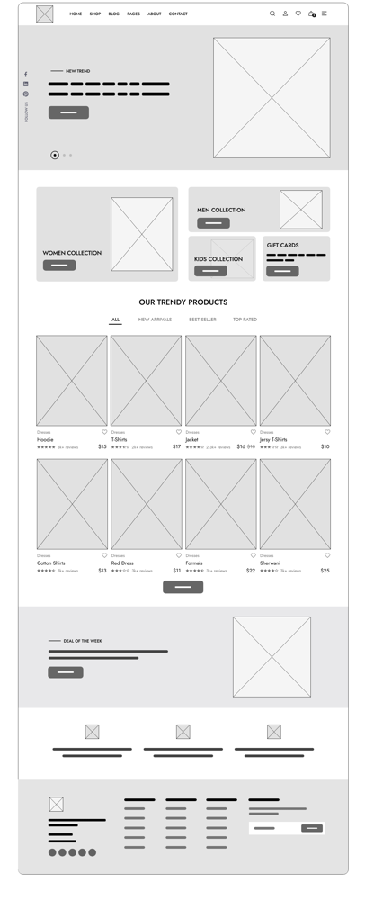
Figure: Example apparel e‑commerce homepage wireframe (source: MockFlow)
- Header: Logo top-left; main nav links (Shop dropdown, About, Contact); utility icons top-right (Search, Account, Cart)[12].
- Hero Banner: Large banner highlighting a promotion or new arrival with a clear CTA button (“Shop Now”)[13]. A carousel/slideshow may cycle through deals.
- Category Section: A row of boxes or cards for key categories (e.g. Sneakers, Shirts, Jeans, Slides), each with an image and a “Browse” button[14].
- Featured Products: Grid of “Trendy Products” showing thumbnails, names, prices, star ratings and review counts[15]. Tabs or filters (All, New, Best Seller, Top Rated) allow quick sorting in place. Each product card has a visible “Add to Cart” button (and optional heart icon to Save).
- Deals/Brands: Section for “Deal of the Week” or featured brands/logos to build trust.
- Footer: Multi-column links (Customer Service, Company Info, Social Icons, Newsletter sign-up). This helps navigation and trust (e.g. link to returns policy, contact).
- Category Page (Web/Mobile):
- Filters Panel (left or top): Collapsible filter groups for Size, Color (swatches with labels), Brand, Price (range slider), etc. Use checkbox filters for multi-select[2].
- Sorting: Dropdown (e.g. Relevance, Newest, Price ↑/↓, Popularity).
- Product Grid: Responsive grid (e.g. 3–4 columns desktop, 1 column mobile). Each card: image, title, price, maybe rating. “Add to Cart” icon and a quick “View Details” link. Pagination or infinite scroll.
- Product Page:
- Main Section: Large product image (clickable thumbnails for other views). Beside it: Product name, price, star rating+review count, short description snippet.
- Options: Clear variant selectors (e.g. size & color) using button-like swatches[6]. A quantity selector with +/- buttons. Prominent “Add to Cart” (primary) and “Buy on WhatsApp” (secondary/colored) buttons. Indicate stock status or “Out of Stock”.
- Details: Tabs or accordion for Description, Specifications, Shipping info, etc.
- Reviews: Section of customer reviews (with images if any), including an “Add a Review” link.
- Related Products: Below, show similar or recommended items (“You might also like”) in a horizontal scroll or grid.
- Note: Show model shots or “in-scale” images for size context (Baymard recommends in-context images for clothing)[16]. E.g. a sneaker on a model or a shirt worn.
- Cart & Checkout (WhatsApp Flow):
- Cart Page: List each item with small image, name, selected options, price, quantity (with +/-), and line subtotal. At bottom: Order summary (subtotal, any shipping, total). Buttons: “Continue Shopping” and “Checkout with WhatsApp”. (If guest checkout is allowed, emphasize as such[17]; no forced sign-up).
- Checkout via WhatsApp: Clicking this opens a WhatsApp chat (via api.whatsapp.com/send?...) with a pre-written message containing the order details[8]. The user sends it to initiate order. The backend can optionally confirm via automated message (using Business API templates) or an agent response[9][10]. No credit-card entry on-site.
- Account Pages:
- Profile/Dashboard: After login, user sees past orders (with status), option to save addresses, and wishlist (if implemented).
- Order History: List of orders with date, items, and statuses; details page for each. Provide “Track Order” info or contact support link.
- Error States: Friendly messages (e.g. “Your cart is empty – start shopping!”). Form fields inline-validate with clear red text near the field[18].
- Admin Dashboard (Custom UI):
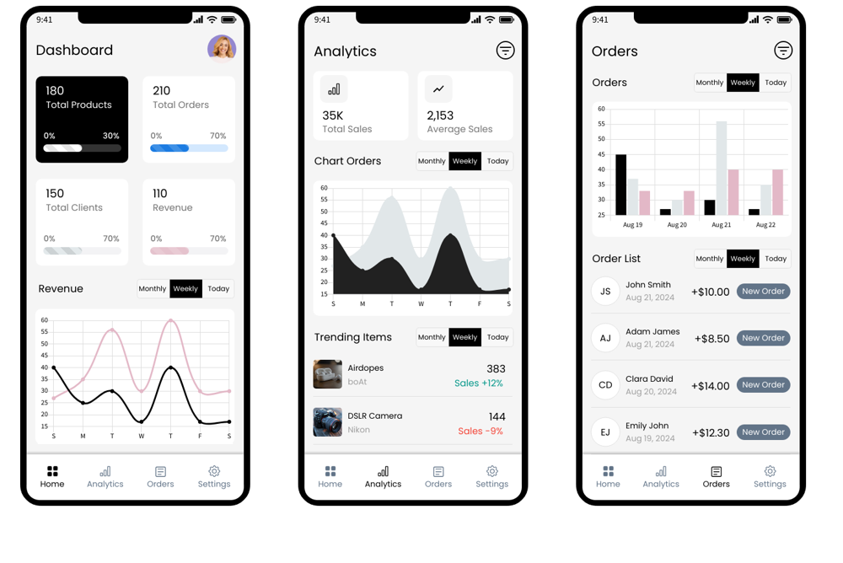
Figure: Example mobile admin dashboard wireframe (source: MockFlow)
- Overview: KPIs at top (Total Sales, Orders Today, Pending WhatsApp Inquiries). Include charts (sales over time, top products)[19].
- Navigation: Sidebar or bottom nav with sections: Dashboard, Orders, Products, Customers, Analytics, Settings. Icons + labels.
- Inventory Management: Table of products (with columns: name, category, stock, price, actions). Filters/sort on columns. An “Add Product” button opens form.
- Orders: List of orders (ID, customer, total, status [e.g. New, Confirmed, Shipped], date). Ability to click into an order to update status or contact customer (via WhatsApp). Include a section for WhatsApp messages received (link to customer chat).
- Analytics: Interactive charts for sales (daily/weekly), inventory levels, and customer trends. Exportable reports (CSV).
- Responsive: The admin UI should be mobile‑friendly (as above example shows) or at least tablet-friendly. Use cards and a clean grid.
Each wireframe element prioritizes clarity and easy navigation. Where possible, follow the MockFlow recommendations (e.g. tabbed filters on homepage)[15] and Baymard’s guidelines (visible “Save” feature, prominent CTAs).

UI/UX Recommendations
- Layout & Navigation: Mobile-first design. Use a clean grid layout (CSS Grid/Flex) so product cards reflow responsively[20][21]. Navigation should be persistent (sticky header on desktop, hamburger menu on mobile). Display the search icon visibly. Ensure click targets (buttons, links) are large enough (min 44x44px). On mobile, avoid “tunnel vision” scopes – label links clearly so users know what list they’ll see[4].
- Product Filters: Use multi-select checkboxes or toggles for size, color (with swatches + labels)[2]. Price slider and category buttons help quick filtering. Show number of results. Collapsible filter groups if many options.
- Sorting: Provide sorting dropdown on category pages (e.g. Newest, Price low→high, Best selling). Remember most users don’t use overly complex sorts.
- Responsive Behavior: Follow modern RWD practices[20][21]: fluid grids (e.g. repeat(auto-fit, minmax(280px,1fr)) for product lists) so layout adapts. Use srcset on images to load appropriate resolution[22], and always include width/height to avoid layout shifts[23]. For smaller screens, collapse filters into an overlay panel. Ensure all elements stack or resize gracefully (test on ~320px, 375px, 768px widths[24]).
- Accessibility: Follow WCAG 2.1 guidelines. Use sufficient color contrast (≥4.5:1 normal text, ≥3:1 large text)[25]. All images have descriptive alt text. Form inputs have labels. Ensure keyboard navigability (e.g. tab order through header, menu, content). Include ARIA roles/labels for custom components. Provide skip links or clear focus styles.
- Microcopy: Button labels should be clear and action‑oriented (“Add to Cart”, “Checkout on WhatsApp”). Error/warning messages should explain issues succinctly (e.g. “Please select a size”). On empty states, suggest actions (“Your cart is empty – start shopping!”). Use the brand voice (streetwear tone, but professional). Provide context on the WhatsApp checkout button (“Tap to order via WhatsApp”).
- Error/Empty States: Inline form validation (e.g. if quantity not set). Message placement next to fields is best[18]. For empty filters or search, show friendly “No products found” and possibly suggest categories.
- Onboarding: On first visit, a dismissible banner or modal could highlight site features (“Browse products or tap the WhatsApp icon to order directly!”). Alternatively, use subtle hints like tooltips on new features. Focus on enabling shopping, not a tutorial overload.

Technical Specifications

Django Backend Models (schema)
Model | Key Fields | Purpose
User | (built-in Django User) + profile data (phone, etc) | Customers (login info, address).
Product | name, slug, price, description, images (FK), stock | Items for sale (sneakers, shirts, etc.).
Category | name, slug, parent (self-FK optional) | Organize products (Sneakers, Shirts, etc).
Order | user (FK), status, total_price, created_at | Customer orders (before WhatsApp).
OrderItem | order (FK), product (FK), quantity, price_each | Line items in an order.
WhatsAppMessage | order (FK), message_body, timestamp, is_from_user | Stores or logs chat messages if using API.
InventoryLog | product (FK), change_qty, timestamp | Track stock changes (optional).
AnalyticsEvent | type, data (JSON), timestamp | For custom metrics (optional).
(See model diagram below table for fields.) Django’s ORM handles relationships (e.g. Order→OrderItem). We would add proper constraints (e.g. stock >=0).

REST API Endpoints
Method | Endpoint | Description
GET | /api/products/ | List products (with filters query params: category, price, brand, etc)
GET | /api/products/{id}/ | Product detail (images, description, variants).
GET | /api/categories/ | List categories/hierarchy.
GET | /api/cart/ | Get current cart (items, quantities).
POST | /api/cart/ | Add item to cart (product, qty).
PATCH | /api/cart/{item}/ | Update cart item qty (or remove if qty=0).
POST | /api/checkout/ | Initiate checkout (gather cart data, create Order, return WhatsApp link).
POST | /api/orders/ | (Optional) Place order if fully on-site.
GET | /api/orders/ | List user orders.
GET | /api/orders/{id}/ | Get details/status of an order.
POST | /api/users/login/ | Authenticate user.
POST | /api/users/register/ | Create new user account.
GET | /api/analytics/ | (Admin only) Get sales stats, top products etc.
(Endpoints would use Django REST Framework or similar.) We would secure endpoints with token/auth and CSRF. The /api/checkout/ call could return a WhatsApp URL using the phone number and preformatted text[8].

Frontend Structure (HTML/CSS/JS)
- Frameworks/Libraries: Use Django templates or a JS framework (e.g. React). For simplicity: Django + Bootstrap or Tailwind for responsive CSS.
- Layout: Base template with header and footer. Templates: home.html, category.html, product.html, cart.html, account.html, etc. Use reusable components (navbar, product card, form).
- Interactions: Minimal JS for UI enhancements: e.g. update cart quantities (Ajax), mobile menu toggle, filter collapse. Avoid heavy frameworks for speed. Use CSS Grid/Flex for responsiveness[20]. Lazy-load product images for performance.
- Third-party JS: Integrate WhatsApp click-to-chat via a simple hyperlink[8]. For the admin side, consider a JS chart library (e.g. Chart.js) for analytics.

WhatsApp Checkout Integration
- Click-to-Chat: The simplest method: on checkout, redirect user to https://api.whatsapp.com/send?phone=[STORE_NUMBER]&text=[encoded order summary][8]. Spaces use %20. Example:
- https://api.whatsapp.com/send?phone=+1234567890&text=Hi%2C+I+want+to+order+%22Product+Name%22+size+M+qty+1.
- Prefilled Messages: Encode the cart contents in the URL so the chat opens with that text. Ensure messages do not exceed URL length.
- WhatsApp Business API (optional): For a more seamless flow, use the Business API (via a provider like Unifonic) to automate messages[9]. E.g., server triggers a WhatsApp Interactive Message with order summary, shipping options, and payment links, all within the chat[9][10]. This requires a paid WhatsApp Business account and developer setup. For a small store, the click-to-chat method is easiest to start.
- Order Templates: Use predefined message templates on WhatsApp if needed (e.g. order confirmation, shipping notification).

Hosting Options
Option | Examples | Pros | Cons | Estimated Cost*
Shared Hosting | Hostinger, Bluehost | Very low cost (~£5–£10/mo), easy setup (one-click Django support on some hosts)[26][27]. Usually includes cPanel/GUI, shared databases. | Limited control, performance may suffer under load, less customization (no root access). Harder to scale. | ~£5–£15/month (basic plan)
VPS (Virtual Private Server) | DigitalOcean, Linode, VPSServer[28] | Full root access; configurable resources; predictable pricing (e.g. £4–£10/mo for small droplet). Good performance and control. | More complex (must configure OS, web server, WSGI, SSL). You manage security/updates. | ~£5–£15/month (small VM)
PaaS (Platform as a Service) | Heroku, PythonAnywhere, Render, AWS Elastic Beanstalk | Handles server management (auto-scaling, SSL, Git deploys), easy to deploy code. Heroku’s free/hobby tier can start free (sleeps), then £7–£25/mo for a dyno[29]. Automatic backups and SSL in many cases. | More expensive for resources (Heroku Postgres £8/mo for Hobby DB). Less direct server control. Free tiers may sleep. Build configuration (Procfile) required. | ~£0–£30/month depending on scale
Managed Django Hosts | PythonAnywhere, OpenShift | Django-optimized, often simpler (PythonAnywhere ~$10/mo basic). Some free tier. | Tied to their environment; scaling may require upgrading. | ~£10–£20/month
*Costs are approximate and vary by region. Domain ~£5–£10/year; SSL can use free Let’s Encrypt.
For a small store, a low-end VPS or PaaS hobby plan is recommended. A VPS gives more flexibility at low cost[28]. PaaS (Heroku/Render) simplifies deployment (with Git push) at slightly higher cost. Shared hosting is cheap but may lack performance.

Deployment, Security, Backups
- Deployment: Use Git for source control. Automate deployment via CI/CD (GitHub Actions to AWS, Heroku, etc.). Ensure code is in a virtualenv, use environment variables for secrets (no hard-coded keys).
- SSL: Must use HTTPS (required by browsers/Google). Use Let’s Encrypt certs automatically (Certbot or provider’s auto-SSL).
- Backups: Regularly back up the database (Postgres/MySQL dump) and media folder (images). Tools: Rclone to cloud storage (AWS S3 or Backblaze). Cron jobs or managed DB backups.
- Security:
- Use Django’s security settings: SECURE_SSL_REDIRECT=True, X_FRAME_OPTIONS='DENY', SESSION_COOKIE_SECURE, CSRF_COOKIE_SECURE.
- Keep Django and dependencies updated.
- Input validation and use Django ORM (prevents SQL injection).
- Ensure strong passwords for admin and SSH keys for server.
- Sanitize any user input shown in messages to avoid script injection.
- For WhatsApp links, validate cart data on server.

Content Strategy & UI Kit
- Branding/UI Kit:
- Colours: Choose a modern streetwear palette (e.g. blacks, grays, one bold accent, white background) that reflects the brand style. Ensure brand colors meet contrast (≥4.5:1)[25] for text. Provide secondary accent (e.g. neon green or orange) for CTAs.
- Typography: Sans-serif fonts for readability (e.g. Open Sans, Roboto). Larger font (≥16px) for body, bold for headings. Fluid typography (clamp()) for scaling[30].
- Icons: Use icon font or SVGs (shopping cart, user, menu, WhatsApp logo).
- Images/Assets: Use high-quality product photography (multiple angles) and lifestyle shots. Optimize images: WebP/AVIF for performance[23], include alt tags. For categories, use consistent imagery style.
- Microcopy: Establish consistent button labels (“Shop Now”, “Add to Cart”), error text (“Field is required”), and confirmation messages (“Order sent via WhatsApp!”).
- Content:
- Product Descriptions: Short bullet points plus a detailed description. Use SEO keywords naturally.
- About/FAQ: Friendly tone explaining brand ethos.
- Blog (optional): If supporting SEO/engagement, include style tips, but not required at launch.
- Customer Reviews: Encourage reviews (perhaps via WhatsApp follow-up link).

Development Handoff Checklist
- [ ] Finalized wireframes and UX flows (labeled).
- [ ] Design assets & UI kit: color swatches, font files, icon set.
- [ ] Sitemap and information architecture document.
- [ ] Written UI guidelines (spacing, button states, etc).
- [ ] Content requirements: placeholder text for products, legal copy (T&Cs, privacy).
- [ ] Django project skeleton: requirements.txt, virtualenv, basic settings.
- [ ] API spec document (endpoints, payloads).
- [ ] Test accounts and test data.
- [ ] Deployment instructions (server setup, env vars, backup plan).

Timeline & Milestones
Phase | Tasks | Duration
Planning | Requirements review, user research, personas, IA/sitemap | 1–2 weeks
Design | Wireframes (lo-fi → hi-fi) for all pages, UI kit | 2–3 weeks
Backend Setup | Django models, database schema, initial data migration | 1 week
Frontend & Templates | Build HTML/CSS for pages (Home, category, product, cart) | 3 weeks
APIs & Integration | Implement endpoints, cart logic, WhatsApp link generator | 2 weeks
Admin Dashboard | Admin pages for inventory, orders, analytics | 2 weeks
Testing & QA | Functional testing, cross‑device testing, bug fixing | 1–2 weeks
Deployment & Launch | Server setup, SSL, final QA, go live | 1 week
Buffer | Contingency (client reviews, revisions) | 1–2 weeks
Total: ~10–13 weeks (~3 months). This agile timeline runs tasks in parallel where possible (e.g. frontend and backend concurrently).

Testing Plan
- Usability Testing: Conduct user tests on wireframes/prototype if possible (get feedback on navigation and checkout clarity). After build, test flows with real users (5–10 users) focusing on core tasks: finding a product, adding to cart, completing WhatsApp checkout. Adjust based on pain points.
- Functional QA: Verify all features work: search results, filters, cart calculations, WhatsApp message format. Test on multiple browsers and devices (mobile iOS/Android, desktop Chrome/Firefox).
- Performance: Test site speed (Google Lighthouse). Optimize images and minimize JS.
- Security Testing: Ensure authentication works correctly. Test for common vulnerabilities (OWASP). Confirm SSL is enforced.
- Accessibility Testing: Use tools (axe, Lighthouse) to check color contrast and ARIA. Manually test keyboard navigation and screen reader labels.
- Regression: After fixes, re-test critical flows (cart, checkout).

Open Questions / Assumptions
- Payment: We assume WhatsApp checkout only (no on-site payment gateway). If card payments are needed, a different flow is required.
- Location/Region: Hosting and currency (e.g. USD, ₦) were unspecified. This plan is general; currency can be set in settings. Region may affect taxes/shipping rules (not covered).
- Inventory/Shipping: We assume shipping is handled offline or via courier; the site will not calculate shipping rates.
- Third-party Integrations: No marketplace (Amazon, eBay, etc.) integration. No social logins assumed.
- WhatsApp Business API: Only the click-to-chat flow is implemented by default. Automated business API use (with interactive templates) is optional and would raise costs/time.
This comprehensive plan should guide the development and design of the ofazyvybez e‑commerce site, balancing modern UX standards with technical feasibility. All recommendations are drawn from established ecommerce UX research[11][1][20] and tailored to a streetwear retail context.

[1] [6] [16] Product Page UX Best Practices 2026 – Baymard Institute
https://baymard.com/blog/current-state-ecommerce-product-page-ux
[2] [3] What Is an Ecommerce Filter? UI Best Practices – Baymard
https://baymard.com/learn/ecommerce-filter-ui
[4] Homepage & Navigation UX Best Practices 2025 – Baymard
https://baymard.com/blog/ecommerce-navigation-best-practice
[5] The 24 Best Sneaker Websites to Buy Your Kicks in 2023
https://www.highsnobiety.com/p/best-sneaker-websites/
[7] [17] Checkout UX Best Practices 2025 – Baymard Institute
https://baymard.com/blog/current-state-of-checkout-ux
[8] How to Create and Use WhatsApp’s Click-to-Chat Link - Freshchat Blog
https://www.freshworks.com/explore-cx/how-to-create-whatsapp-link/
[9] [10] Automated WhatsApp Checkout Integration Guide | Unifonic
https://www.unifonic.com/en/resources/automated-whatsapp-checkout-integration-guide-unifonic
[11] Ecommerce Website Wireframe Template | Moqups
https://moqups.com/templates/wireframes-mockups/websites/ecommerce-wireframe/
[12] [13] [14] [15] Low Fidelity wireframe example for ecommerce home page - MockFlow
https://mockflow.com/wireframe-examples/low-fidelity-wireframe-example-for-ecommerce-home-page
[18] 10 Design Guidelines for Reporting Errors in Forms - NN/G
https://www.nngroup.com/articles/errors-forms-design-guidelines/
[19] Admin dashboard wireframe example for mobile app - MockFlow
https://mockflow.com/wireframe-examples/admin-dashboard-wireframe-example-for-mobile-app
[20] [21] [22] [23] [24] [30] Responsive Design: Best Practices & Examples | UXPin [2025]
https://www.uxpin.com/studio/blog/best-practices-examples-of-excellent-responsive-design/
[25] Contrast Checker - WebAIM
https://webaim.org/resources/contrastchecker/
[26] [27] [28] 8 Best Cheap Django Hosting Services in May 2026
https://hostadvice.com/django-hosting/cheap/
[29] AWS vs Heroku Pricing : r/django - Reddit
https://www.reddit.com/r/django/comments/mnc199/aws_vs_heroku_pricing/

